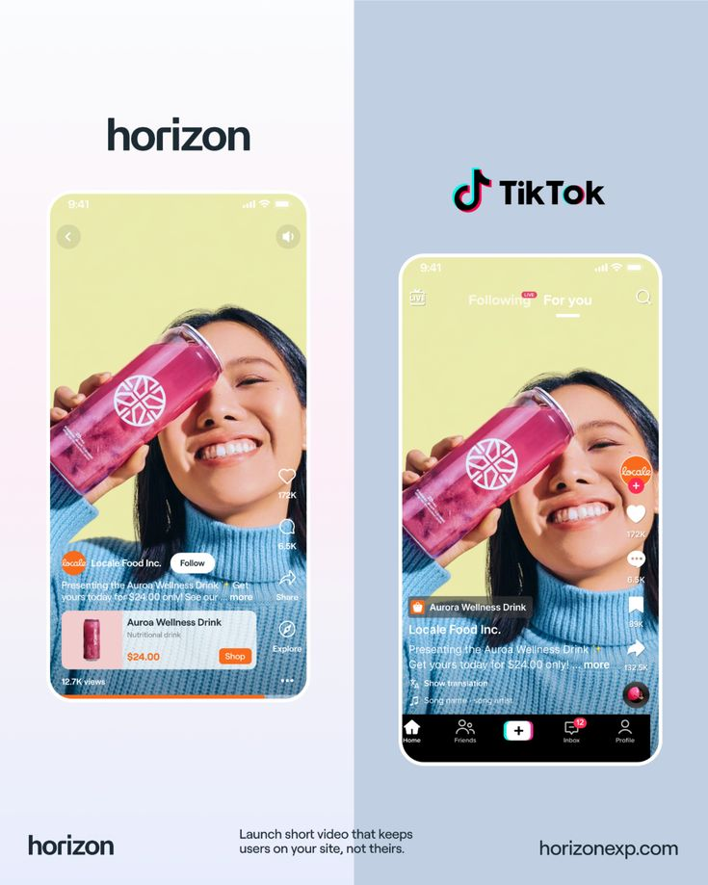

Amamaza landing site tweaks

HERO SECTION
The loading words 95% perfect cause its loads the folded phone which I like but the phone frame is not straight facing ahead its some hhow slanting at a cetan angle so ineed you to fix tehis and you know the first image on the folded pheon is our logon in the white Bg but also add amamaza below the icon
On tehbanner image its filling the whole space but many edge parts are not visible so find awy or create aperfect iage to show the high quality shop banner image that we make may be ona shop entrance so that that image shos the kind of printable banners amamza produces.
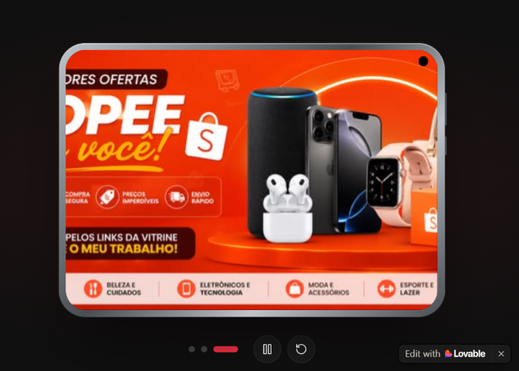
Aagin I need you to remov those small cirles and the icons bedised it the play and pause butto and retry and make keep the auto start to play o my videos and iages and give the images a perft period fr the to switch where a person can easily see tehm quickly but don’t over speed just add a reasonable period
Mainly I wsh my hero section to feel like designed by real desigers not an AI and I want it to mimic the look of dribble’s Hero section
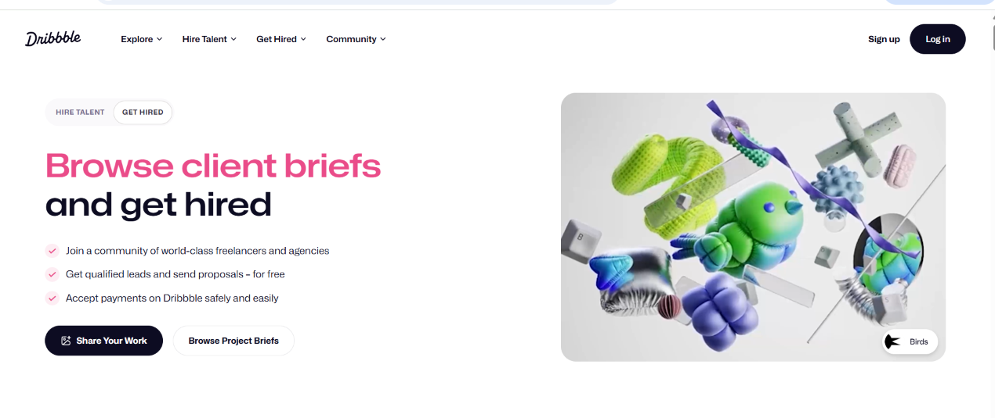
Look at it and compare it with mine youll see a big difference for its site its so clean from its logo ,to the navbar (but for mine keep tehir alignment and position but mke tehm look like that )
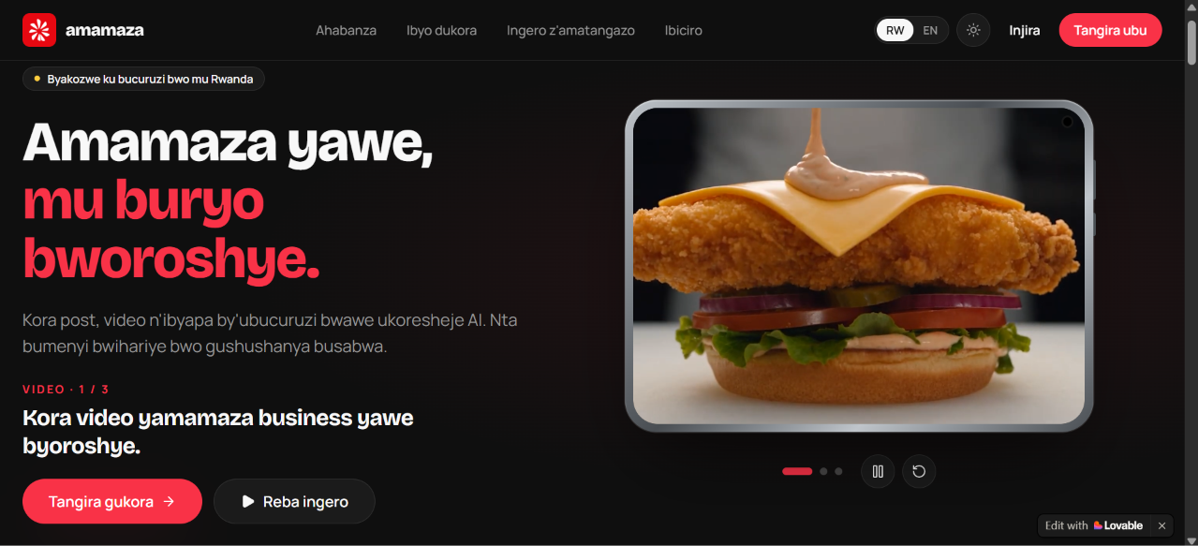
Unlike my site look at the way the top nav looks on dribble eve when I scroll up .it stays white no gradient and I also want you to redesig my site typography by using apple fonts to make it look premium and if its free to use for our site commericially and if not look for 100% or cloer looking free font but I prefer apple fonts if tey are free to use.
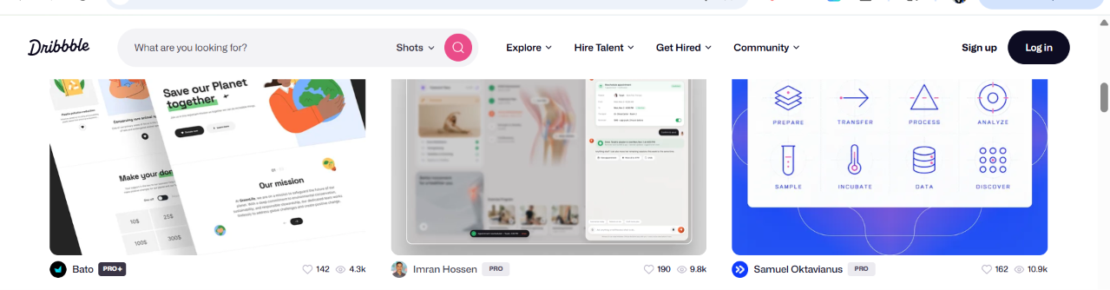
Lets return to dribbles loved parts look at the way it has A minila hero section which looks so calm and for our site I need you to remove that pill that says “built for Rwandan businesses “cause its generic for ai made sites.
Instead lets mimic or enhance our hero section to match dribble or our current strategy the headlines should be “Kwamamaza ibikorwa byawe(this part should be in our red color and above the next part as dribble does it in only 2 short senteces), ubu Byoroshye!” then below that headline the description or sub headine will hav ths dynamic texts “Ubu ushobora kwikorera {video}zamamaza ibicuruzwa na serivisi utanga byihuse kandi mu buryo ushaka.”
On that {} part we shall update it with {social media post} and {ibyapa but here we shall change the next word to “byamamaza”} so find the sweet translation iin eneglish mode.
The dynamic words should be in red.unlie the surrounding words and give it a medium size to make the changes visible.
Below that description add the start creating button then a “Download now” button in Kinyarwanda donload is {Downloadinga application}.so remove the video 1/3 part ad its headline below it and no see exmaples.agin notice that the white bacgroudn on dribble is so cleaner than mine and now I need you to implement the same clean white may be plain whiete.
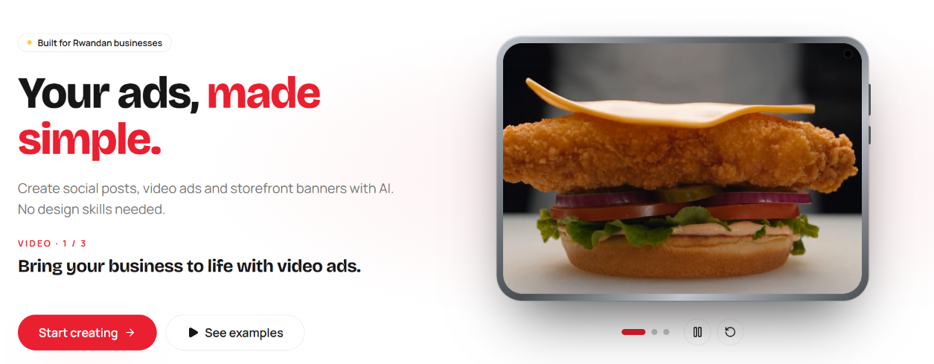
On mobile phones the folded and unfolded phoen should be perfectly in the center and stay tehr ein the center with the headlines below it .
I geuess now were done with ethe hero section and it will eb folwed by that the problem solves section so don’t touch it for now reduce the space between sections but make thm transiction look smooth and clean white no problem.
Instead lets move to the next section .Teh trending section[Ibyamamaye in kinyarwanda] use our selected font both on trednng ans se what others are creating .The first thing I noticed is that eth top nav is gradiented instead it should stay clean white as dribble if I in light mode and clean calm dark when in dark mode ,
IIn light mode use our clean white on this section of trending and calm professional dark when in drak mod cause currently both light and dark mode display that section as dark which is bad.
Agin I want you to remove the “All” tab pill instead keep ([videos,posts,banners]in kinyarwanda[video,amapost,ibyapa])and make thse pills look like professional made on popular sites not look like ai made
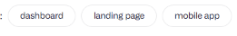
Each pill should look unique to let people get curious to explore tehse pages and the first pill for videos should have our red background with the clean white font color,the posts page should have a sky blue bg ,the banners pill should have a premium bright light grenn bg.
Lets go below these pills I want to redesign the cards and the look if the cards.i want us to redesign my videos and posts tab cards to look like Instagram designs they should have the sharp edges no rounded corners just make my images cards there look 100% like the image below and make that section to also be centred leik this image layout of Instagram on desktop

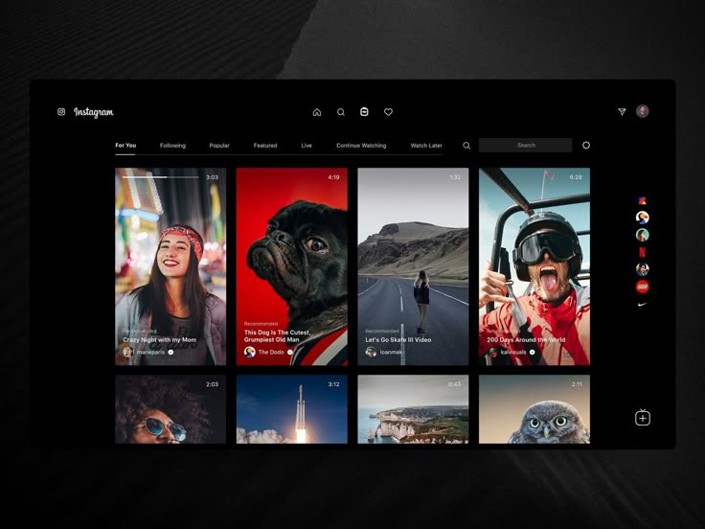
On our video cards keep that top time and progress line but remove the account pofie avatar on them but keep that video title.keep the rows on each tab 2 and add a red clean button on the right fo rteh user to open and view more videos /posst /banners so it should be tehre as on those profile avatrs on the reference image of instagram provided above.
When the user clicks on a certain video or image it should open like instagram/tik tok so it should popup a clean rectangular card with the video on the left .teh on the right tehre should be its title and description as used on canva then “make similar/kora ibisa nkibi” button in our red like pinterest buttons(ytake a reference on that continue button. Besides the make similar button add a love button to implement the like feature which wil eb shown below the heart icon on the individual video. Ad make sure that love button is also on the video card and when liked do the isntgara like animation and allow double tap to like feature.allow liking even when users don’t ave an account.
Then below it there are comments where its shows all comments that people commented
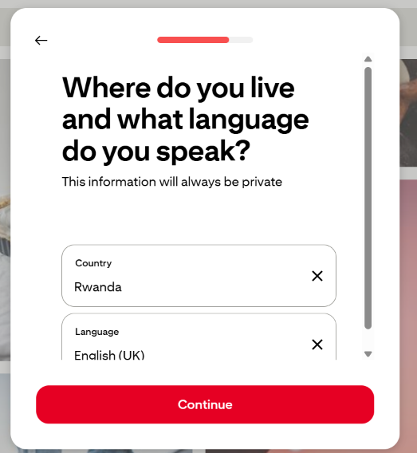
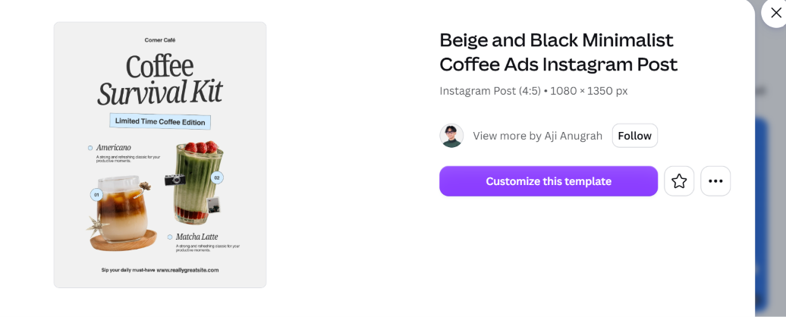

Unlike the videos tab and the pposts tab the banners tab will have well oragnizsed rectangles which are wide and make the layout unique to disply different examples of banners of different business from the wide banners to the pull ups and roadside banners.kepp the layout clean and easy to scan the beauty oand quality of workconsder showcasing different types of businesses and mainly those in Rwanda t make Rwandans feel that ist customized for tehm ..
Let’s now move to what we do section first of all don’t make that title too far form the previous section and lest start wuthe the “shot videos for your business section”
Firstly remove that purple pill of “video ads” tehn keep the texts and ets edit its asset on the right side because its for videos I wish that you display use a clean iphone or Samsung phone frame but which were allowed to use on our commercial site and kepp it sides so smooth and now show our ad videos being played on tik tok so make it n awy ill upload my video on githb [the video has been uloaded in public/ads/ amamaza-video-section-ad.MP4]then it fits into the phoen and be shown as if its being plyed perfectly on tiktok with the like buttonand views growing rapidly and around the phone frame ass few stickers of Instagram,WhatsApp,like and share button and keep tehose sticker icon so clean ad nor over crowded and make tehm stay close to the frame not scattered around .and the video should really play automatically when I reach tehre and give this section a specifis bg color which is clean to fit with our red brand (ahaa ets use colors that atches those weve used on thetredning pills for red use a red which goes to be pink but keep it calm and if possible .i want tehse section to be colorful and enegaing to see without affecting ethe eyes and be adaptable to both our light and dark theme.
Below it were moving to another sction of social media posts{ama photo yo kuri social medias}
In its description add or mention these social media sites Rwandans love to use like WhatsApp,tik tok,Instagram and facebook.again lmake its button use it light blue color tehn lest talk about its assets which are on the left for thisection.[on the left you should add an image which has 3 businnses posts related to popular Rwandan businesses [cards arranged like instagram login image cards (left:fashion shop,center:drink product image,right:furniture product)]
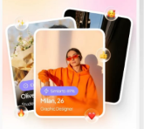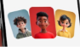
Do it in a wy that all will be well seen and if possible add very few sticker around tehm inclusinga buy now badge .to show conversion of our clients ads.
In all section keep ur clean whie so dominant and same when I shif to dark tehm so dark sudl look perfectly tehre with the unique colors or gradient of teach section.
The last section is for banners
Also start by removing that top yeloe pill above it tehn translate the headline with “Icyapa cyo hejuru y’iduka ryawe”.tehn remebe rthis section is for our light gree like duolingo bright green. And the button .
Lest movw to the asset on its right side .its also so unique than any other section of the site cause below this section there will be a clip coing behind eh ledge an its fron part holding 2 cards teh front one with teh image of teh banner while its background one has our red pink color .help with teh clip lie as if teh images are on a wall
.But for our card the fron image add tehre a clean banner on top of a shop enetrance on the road side again the backcard whould look like red-pink and no other card.
The follwing sections looks fine .so make this perfect and redeing fully my site and make sure every major step you make goes immediatle to github.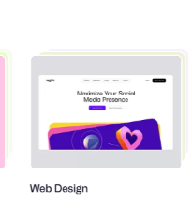
On the talk to prose section on phhones make that image be in the center instea do f right side
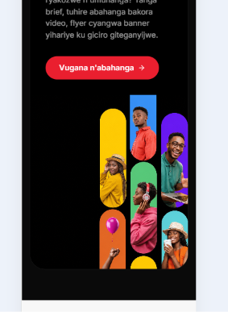
Here is where the first bob had stoped when implementing the chagnes
Your workspace ran out of credits, so I only finished part of the redesign. None of it has been checked in the preview yet.

[Done:
- Fonts: The site now uses Apple's own font on iPhones and Macs. Apple doesn't allow its fonts to be loaded on other devices, so those show Inter, a free font that looks very close.
- Hero phone: It now faces straight ahead instead of sitting at an angle.
- Hero background: It is now plain white in light mode and calm dark in dark mode, with no glow behind it.
- Section colours: I set up the soft pink-red for videos, sky blue for posts and bright green for banners, in both light and dark mode. The sections don't show them yet.
- New images: I made four new pictures. One is a Mama Keza Supermarket shop in Kigali with the whole banner visible above the entrance. The other three are a fashion post, a juice post and a furniture post. They aren't on the site yet.

Not done yet:
- Hero:
- "amamaza" written under the logo on the folded phone
- your new red headline and the changing red words
- the "Downloadinga application" button
- removing the small pill, the "1 / 3" line, the dots and the play, pause and replay buttons
- slower picture timing
- centring the phone on mobile
- Top menu: the clean, solid Dribbble-style menu.
- Trending section:
- light and dark versions
- red, blue and green tabs, with "All" removed
- sharp-cornered Instagram-style cards in two rows, with a red "see more" button
- the wide banner layout
- the pop-up with "Kora ibisa nk'ibi", likes (double-tap and heart animation) and comments
- Video section: the TikTok-style phone playing your video, with growing views and stickers.
- Posts section: the three-post fan with a "Buy now" badge and the four social apps named.
- Banner section: the "Icyapa cyo hejuru y'iduka ryawe" headline and the clip holding two cards on a wall.
- Spacing: less space between sections.
][fo rother non apple user I suggest usng inter or the fnt that google uses on its product cause it looks unique]
Your changes go to GitHub automatically, so you don't need to do anything for that. Once you add credits, tell me to continue and I'll finish the rest.

Because you cant acccess my githb for you continue form wheere my first bot stopped the finish the rest of the work and give me the ready zip file which ill give back my bot to implement al chnages on my repo .

